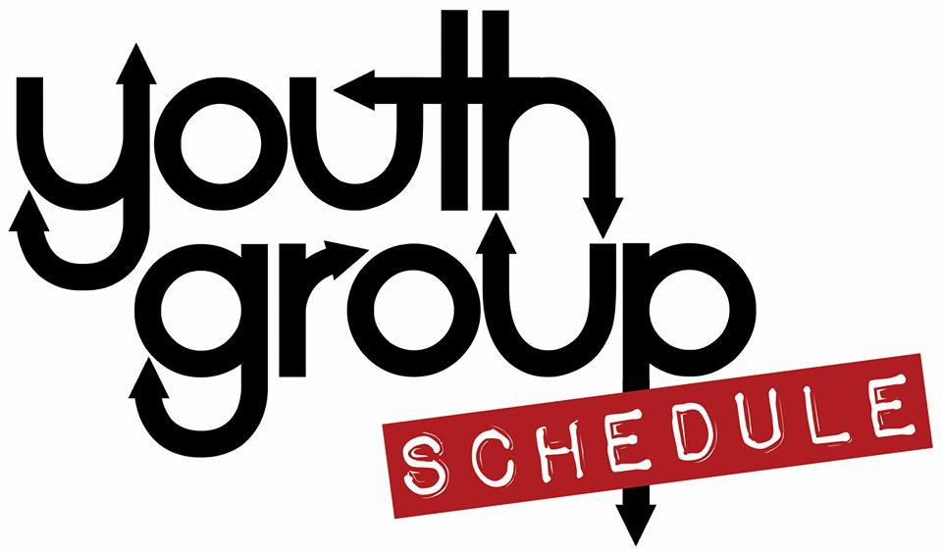  September  23rd - Youth Group 6-8pm at the church  30th - Youth Group 6-8pm at the church  October  7th - Youth Group 6-8pm at the church  14th - Youth Group 6-8pm at the church  20th –Trip to Oasis Island of Terror Halloween trip – See permission slip  21st - No Youth Group  28th- No Youth Group – Jean’s Retirement Party  November  4th - Youth Group 6-8pm at the church  11th - Youth Group 6-8pm at the church (Pie order forms due)  18^{h}- NO Youth Group  21st - Pick up Thanksgiving fundraiser pies – 5pm at church  25th - NO Youth Group – Thanksgiving  December  2nd - Youth Group 6-8pm at the church  9th - Youth Group 6-8pm at the church – Christmas Party  Bring a wrapped $10 secret Santa gift.  16th- Christmas Caroling - time TBD  23rd - NO Youth Group – Christmas  30th - NO Youth Group – New Years  January  6th - NO Youth Group – New Year’s Day  8th - Youth Group 6-8pm at the church |  | The youth group will start taking orders for our annual Thanksgiving pie sale on 10/14 and pies can be picked up at the church on 11/21 from 5-6pm. Order forms will be given out in October.  2018  In November we will be making Hygiene bags for the Trenton Area Soup Kitchen. Please bring 10 individually wrapped bars of soap and 10 disposable razors by November 4th.  Megan  (609)439-1435  MeganGadsby@gmail.com
6th - Youth Group 6-8pm at the church

